What is food policy? Class outline for teaching at Hebrew University, Israel, 8-16th January 2017
Martin Caraher
Professor of Food and Health Policy
Centre for Food Policy D110
Dept of Sociology
School of Arts and Social Sciences
Northampton Square
City, University of London
London EC1V OHB
T: +44 (0)20 7040 4161
E: m.caraher@city.ac.uk
W: http://www.city.ac.uk/people/academics/martin-caraher#profile=overview

Introduction
Food policy is more than the study of the relationship between food and the human experience. It is concerned with more than health and more than just agricultural policies or even nutrition policy as individual strands, it is the interconnectedness and sometimes even the disconnect between these various areas. In the global north the emerging problems of food insecurity combined with overconsumption have placed strains on healthcare budgets and on ecological sustainability. Food policy has come to the fore in areas such as development studies where the double burden of overconsumption and overconsumption has lead to major problems for healthcare, the demise of local agricultural systems, flight from the land and rising levels of food insecurity.

The Centre for Food Policy at City, University of London [https://www.city.ac.uk/arts-social-sciences/sociology/centre-for-food-policy], where I work, is one of the very few places in the world dedicated to studying, teaching and influencing food policy. Established in 1994, the Centre pioneered what was then a new approach to food policy, an approach that brings together policies that affect food production and consumption, supply chains, processing, retail, marketing and the impacts on environment and livelihoods, health and nutrition and so on. This holistic, food systems approach is the core of who we are and what we do. It’s the way we will find solutions to so many problems in the world today.

Our perspective is global. While people experience their food system at a local level, what happens in the food system in one place is affected by what goes on elsewhere. What happens in wealthier countries affects low and middle-income countries and vice versa. Better policies are needed at the local, national and global levels to leverage these connections and influence change.

Many of the reading s below will draw on my research, this is not because I am that well known or the only person writing in this area, but for a more pragmatic reason. Using my publications I can make them available to you and copies can be downloaded from the following website
https://www.city.ac.uk/people/academics/martin-caraher#profile=publications

Some core reading
Lang, T., Barling, D. and Caraher, M. (2009). Food Policy: integrating health, environment and society. Oxford University Press, Oxford.
Caraher, M. and Coveney,J. (Eds) (2016). Food Poverty and Insecurity: International Food inequalities. Springer, Switzerland.
Caraher, M. and Coveney, J. (2004). Public health nutrition and food policy. Public Health Nutrition, 7(5), 591–598.
Carey, R., Caraher, M., Lawrence, M., & Friel, S. (2015). Opportunities and challenges in developing a whole-of-government national food and nutrition policy: lessons from Australia’s National Food Plan. Public Health Nutrition, 19(1), 3-14. doi:10.1017/S1368980015001834
George, S (1976) How the Other Half Dies: The Real reasons for World Hunger. Available as a free download. https://www.tni.org/en/search?search=How+the+Other+Half+Dies%3A+The+Real+Reason+for+World+Hunger&sort_by=search_api_relevance
Caraher, M. and Cavicchi, A. (2014). Old crises on new plates or old plates for a new crises? Food banks and food insecurity. British Food Journal, 116(9); doi.org.wam.city.ac.uk/10.1108/BFJ-08-2014-0285 .

Class 1 Introduction to food policy and food systems (Sunday 8/1/2017)

What the lecture will be about
This first session will explore definitions and the development of “food policy” and what we mean by food systems. It will set out the challenges of defining food policy and the history and context of the use of the term from the early 20th Century onwards. It highlights the importance of the integrated approach to food policy and point out the major conflicts and tensions in food policy.

What you need to do to prepare for the class
Chapter 1 in the book Lang, T., Barling, D. and Caraher, M. (2009). Food Policy: integrating health, environment and society. Oxford University Press, Oxford
Think about what you associate with food policy and how it might relate to food systems?

Class 2 Globalization, the Nutrition Transition, Nutritionism and Global Equity (Monday 9/01/2017)

What the lecture will be about
The lecture will be on the role of the policies and processes of globalisation in transforming the food policy space internationally. This will relate to the topic of food systems covered in class 1. It will define globalisation and the theories and ideas that propelled it forward. It will describe the specific food-related policies that have taken it forward and analyse how these policies have wrought changes throughout the food system. For example
If we think of the world as a global table with ten people sitting down for a meal; organised by population 2 are Chinese, 2 are Indian, 1 is from NE, S and Central Asia, 1 from SE Asia and Oceana, 1 from Sub-Saharan Africa, 1 for the remainder of Africa and the Middle East, 1 for Europe and the last for south, central and North America. Yet if organised by nourishment one is hungry, two are obese, more than half eat a mainly vegetarian diet, with strict vegans occupying one seat, organised by consumption America occupies 3 seats
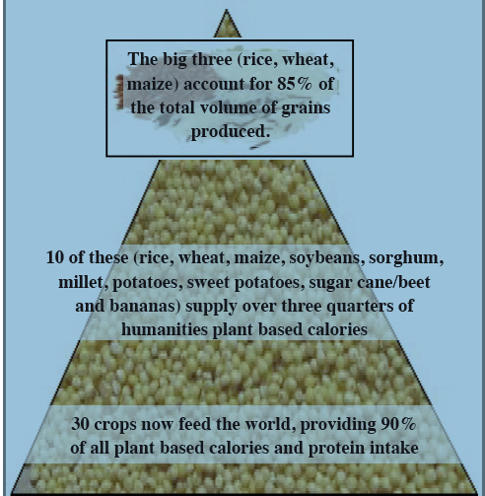
Issues related to choice will be dealt with along with the illusion of choice which is often called pseudovariety. Some of this can be seen in the following diagram. The tension between the consumer and citizen will also be drawn out.

What you need to do to prepare for the class
Read Caraher, M. (2011). Food Austerity: a lifestyle choice for whom!. Journal of the Home Economics Institute of Australia, 18(2), 17-25.
Chapter 7, Behaviour and Culture in Lang, T., Barling, D. and Caraher, M. (2009). Food Policy: integrating health, environment and society. Oxford University Press, Oxford

Class 3 Supermarketisation and Concentration in the food chain

(Tuesday 10/01/2017)

What the lecture will be about
This class will lead on from lecture 2 and build on some of the key concepts of consumer versus citizen rights. The ‘supermarket revolution’ is the outcome of 2 developments: an agrifood supply chain revolution and an urban food provisioning, or consumer, revolution, such processes result in:
- A small number of supermarkets come to dominate food retail in any one country.
- Small chains and single store formats disappear due to a lack of competiveness and mergers and acquisitions.
- Policy regulators concern themselves with competition between ‘the majors’ and not the majors and minors, often driven by the political imperative to drive food prices down.
The context for all of this can be seen in the following example of global spending on advertising. Spending will increase in 2016, with large food companies the second biggest category after the automotive industry. These food companies are predicted to spend $30.7 billion on advertising and promotion, compared to $30.4 billion in 2015. Oxfam (2013) estimates that worldwide, 500 companies control 70% of food choice. They identify ten powerful global food and beverage corporations, employing millions around the world and generating revenues of more than $1.1 billion a day. The global reach and influence of these companies is significant–their annual revenues of more than US$450bn equate to the GDP of all low-income countries combined, which the World Bank puts at US$392.9bn in 2015.

What you need to do to prepare for the class
Read one of the following:
Dixon, J. (2015) IUHPE Position Paper: Advancing health promoting food systems. International Union for Health Promotion and Education (IUHPE), Saint-Denis, France.
Dixon, J. and Banwell, C. (2016) Supermarketisation and rural society futures. In Shucksmith, M. and Brown, D. Routledge International Handbook of Rural Studies, Routledge, pp. 227-239.
Dixon, J. (2008) Operating Upstream and Downstream; How Supermarkets Exercise Power in the Food System. In Germov, J. and Williams, L. (2008) A sociology of food and nutrition: The social appetite. 3rd Edition. Oxford University Press, Oxford. pp 100-123.
Cairns, G., Angus, K., Hastings, G. and Caraher, M. (2013). Systematic reviews of the evidence on the nature, extent and effects of food marketing to children. A retrospective summary. Appetite, 62, 209-215. doi: 10.1016/j.appet.2012.04.017

Class 4 Examples of alternative food networks and activism (Wednesday 11/01/2017)

What the lecture will be about
Food issues have been climbing the public agenda in recent years: anxieties about safety and trustworthiness, school meals and children’s eating habits, and obesity/anorexia trigger media and anecdotal attention. In particular, policy makers charged with reducing inequalities, exclusion and poverty, have seized on community based food initiatives as a means of solving what are perceived to be the particular food problems of those who are poor, lack skills and decent affordable shops nearby. Alternative networks to the conventional food systems have emerged farmers markets, food hubs, retail food co-op, growing and land sharing schemes. The list is endless. The kibbutzim tradition in Israel is an example of this tradition. Despite this there is little evidence of these initiatives achieving much. The dominant food system continues to grown and consolidate so what is the role of the alternative networks?
What you need to do to prepare for the class
Read 2 of the following:

Caraher, M. and Dowler, E. (2014). Food for Poorer People: Conventional and 'Alternative' Transgressions. Goodman M, and Sage C, (Ed.), Food Transgressions Making Sense of Contemporary Food Politics (pp. 227-246) Ashgate, Farnham Surrey.
Shapira, R (2008) Transforming Kibbutz Research. Trust and Moral Leadership in the Rise and Decline of Democratic Cultures. New World Publishing, Cleveland, Ohio.
Knupfer, AM (2013) food co-ops in America: Communities, Consumption and Economic Democracy. Cornell University Press, USA.
Go to Mark Winne’s website http://www.markwinne.com and read his blogs on food policy councils.
Caraher, M., Smith, J. and Machell, G. (01 May 2015). To co-op or not to co-op: a case study of food co-ops in England. Journal of Co-operative Studies, 47(2), 6-19.
Dowler, E. and Caraher, M. (2003) Local Food Projects: the New Philanthropy? Political Quarterly, 74, (1), 57-65.
Guthman, J. (2011) Weighing In: Obesity, food justice, and the limits of capitalism. University of California Press, Berkley.
Guthman, J. (2004) The Trouble with ‘Organic Life’ in California: A rejoinder to the ‘Conventionalism Debate. Sociologia Ruralis, 44: 3; 301-316. DOI10.1111/j.1467-9523.2004.00277.x.
Counihan, C. and Siniscalchi, V. (2014) Food activism: agency, democracy and economy. Bloomsbury, London.

Class 5 Food, public health and the environment (Thursday 12/01/2017)

What the lecture will be about
This class takes the sometimes thorny issue of sustainable diets to conclude the whole module. The term sustainable diet was first used by two US nutritionists (rare in that they were and are interested in environmental nutrition) in a 1986 paper. This articulated the much older case for eating within environmental limits. World best seller books like Moore Lappe and Collins' 1971 book 'Diet for a Small Planet' had made the case much earlier. But the Gussow and Clancy case was that this ought to be formalised. Why is the UN support for nutrition guidelines at the national level not being expanded to include environmental (and cost or cultural) factors? This is the Sustainable Diet debate. The issues of integrated food policy across sectors such as health, environment, business and export will be explored. In this class, the following will be explored:
- can we agree about what is meant by sustainable diets?
- should there be official guidelines - so called Sustainable Dietary Guidelines (SDGs)?
- what is the pressure for and against this policy development

What you need to do to prepare for the class
Read one of the following:
Lang, T. (2014) Sustainable Diets: Hairshirts or a better food future? Development, 57(2), (240–256) © 2014 Society for International Development 1011-6370/14
Garnett, T. (2014) What is a sustainable healthy diet? A discussion paper, Food Climate Research Network. Available for download from http://www.futureoffood.ox.ac.uk/people/tara-garnett
Chapter 6, The environment and ecosystems in Lang, T., Barling, D. and Caraher, M. (2009). Food Policy: integrating health, environment and society. Oxford University Press, Oxford.

Class 6 (Sunday 15/01/2017) Doing food policy: Actions and analysis.

What the lecture will be about
Food policy is the result of many interacting forces, vested interests, resources and differing agendas (health vs agriculture), differing contexts, civil society pressures and much more. The food system is complex and is representative of many interests and competing claims. This class will ink with the content of class 5.
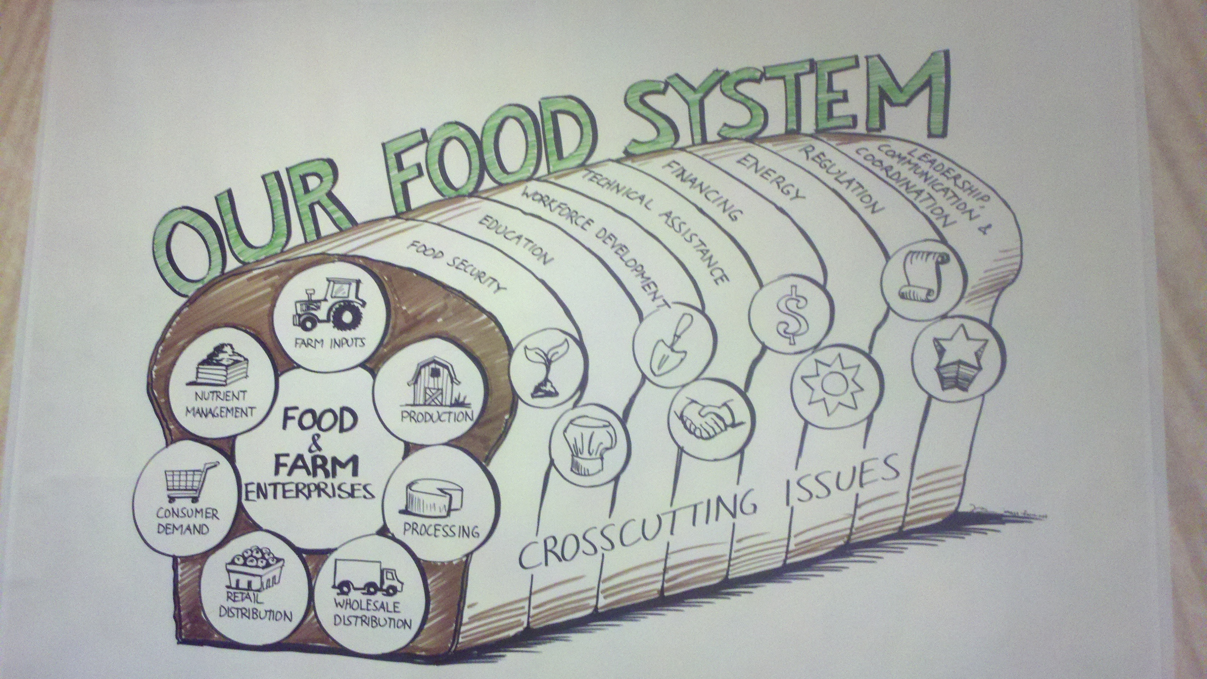
So food policy as a practice looks to incorporate all the elements that influence food and looks to how we might bring about changes in the food system as opposed to simply pursuing individual choice approaches to food consumption. Think of food policy councils covered in class 5.

The sessions will explore how food policy is formed, research methods for food policy and the practical ways to go about establishing food policies. The tensions between top-down and community or bottom-up approaches will be explored as well as stresses between industry and civil society in the development of food policies. Examples from around the globe will be used to illustrate the issues and students will be encouraged to come along with their own examples of food policy.

What you need to do to prepare for the class
Read 2 of the following:
Read chapter 9 On what terms ecological public health’. In Lang, T., Barling, D. and Caraher, M. (2009). Food Policy: integrating health, environment and society. Oxford University Press, Oxford.
Panjwani, C. and Caraher, M. (2014). The Public Health Responsibility Deal: brokering a deal for public health, but on whose terms?. Health Policy, 114(2), 163-173. doi: 10.1016/j.healthpol.2013.11.002
Carey, R., Caraher, M., Lawrence, M., & Friel, S. (2015). Opportunities and challenges in developing a whole-of-government national food and nutrition policy: lessons from Australia’s National Food Plan. Public Health Nutrition, 19(1), 3-14. doi:10.1017/S1368980015001834.
Caraher, M. and Coveney J. (2004). Public health nutrition and food policy. Public Health Nutrition, 7(5), 591–598
Buse, K., Mays, N. and Walt, G. (2012) Making health policy. McGraw-Hill Education (UK).

Exam (Monday 16/1/2017)

